

18th Annual
Information Technology
Conference and Expo

October 12 - 13, 2009
Crowne Plaza Hotel
4728 Constitution Avenue
Baton Rouge, Louisiana

CISD Technology Conference and Expo
October 12-13, 2009
Crowne Plaza Hotel
Baton Rouge, Louisiana
Dear Conference Participant:
On behalf of the Council of Information Services Directors, it is our pleasure to welcome you to the 18th Annual CISD Technology Conference and Expo. This year’s conference features an outstanding selection of speakers addressing a wide variety of topics of interest to Louisiana’s IT professionals.
The conference provides a unique opportunity for you to network with your professional peers, suppliers, and industry experts. Use those interactions as a catalyst to gain perspectives and insights on your current projects, operational issues, and management challenges. Leverage the combined knowledge of nearly 800 IT professionals to help deliver top quality IT services to our ultimate customer – the citizens of our great State. In all, consider the Annual Conference as an important tool in your solutions kit for any facet of IT management and operations – now and well after the conference concludes.
The conference features an exhibition hall, which showcases products and services from 34 state and national vendors providing hardware and software support, telecommunications, consulting, networking, and security services. The exhibition hall will be open both days and we encourage you to visit with all the exhibitors. Remember, they are at the conference for YOU.
As CISD members, we are proud to be your hosts. If you have questions or need assistance, please locate one of the members, wearing a blue CISD shirt or ask for assistance at the registration desk. Thank you for attending the 18th annual CISD Technology Conference and Expo. It is your participation that truly makes this conference a success.
Sincerely,



Michael Carl | Gregory Speyrer
2009 CISD Conference Chair | 2009 CISD President

PROGRAM - OCTOBER 12, 2009
7:30 |  | Registration and Continental Breakfast
8:00 |  | Vendor Expo Opens
8:45 |  | Opening Ceremony
 |  | Posting of Colors
 |  | Pledge of Allegiance
 |  | National Anthem
9:00 |  | Welcome
 |  | Greg Speyrer, CISD President
9:05 |  | Streamlining Government Through IT Service Delivery
 |  | CIO Ed Driesse, State of Louisiana
10:00 |  | Break – Sponsored by Microsoft
10:30 |  | Mobility with Smart Phones – Shifting out of First Gear
 |  | Dave Coley, Research in Motion
11:15 |  | Lunch
12:30 |  | 7 Sins of Backup and Recovery
 |  | Jerry Gaillard, Unitrends
1:30 |  | Unified Communications – Preparing for the Next Generation of Communications
 |  | Brent Byrnes, Cisco
2:15 |  | Break
2:45 |  | Remote Visualization for Cloud Computing and its On Demand Users
 |  | Earl Dodd, IBM
3:30 |  | How to Build a National Champion
 |  | Paul Mainieri, LSU Baseball Head Coach
4:15 |  | Vendor Area Closes
4:30 |  | Conference Day 1 Ends
 |  | Vendor Sponsored Events
4:30 |  | Jazz Reception
 |  | Sponsored by CGI, AT&T and Dell
Poolside TIKI Party
Sponsored by Carrollton Technology Partners
6:00 |  | Vendor Hospitality Suites

PROGRAM - OCTOBER 13, 2009
7:30 |  | Registration and Continental Breakfast
8:00 |  | Vendor Expo Opens
8:30 |  | Choosing the Right Client Computing Architectures for your Organization
 |  | Mark Margevicius, Gartner
9:15 |  | Louisiana's Role in Cyber Innovations
 |  | Craig Spohn
 |  | Executive Director/President, Cyber Innovations Center
10:00 |  | Break – Sponsored by Cisco
10:30 |  | Google, Cloud Computing, and Innovation
 |  | Jeff Roussel, Google
11:30 |  | Lunch
12:15 |  | Registration Closes
12:30 |  | Vendor Area Closes
12:45 |  | Oh no, not another motivational talk on people skills!
 |  | Maurice Velasquez, Wolf Creek
1:30 |  | IT Service Management – Doing more with less:  Are you delivering “the right” IT services?
 |  | Reginald Best, Deloitte
2:15 |  | Break
2:45 |  | Windows 7 in the Enterprise
 |  | Kepp Andrews, Microsoft
3:30 |  | Closing Remarks
 |  | Greg Speyrer, CISD President
 |  | Conference Ends

Lunch Menus:
October 12: Asian Chophouse Salad, Hoisin Lacquered Chicken with Pineapple Confetti Rice and Stir Fried Veggies. Deserts at the Table: Triple Mousse Cake and Carrot Cake
October 13: House Salad, Rosemary Skewered Shrimp with Vegetable Risotto and Grilled Asparagus. Deserts at the Table: Chocolate Strawberry Cheesecake and Bourbon Pecan Pie

Monday, October 12
Ed Driesse
(9:05am – 10:00am)
Edward Driesse was appointed Chief Information Officer for the state of Louisiana on July 22, 2008 by Commissioner of Administration Angele Davis. He is from Lafayette and has 15 years experience as a chief information officer in both the public and private sectors, including three Fortune 500 companies.
Driesse served as CIO for the Department of Health and Hospitals from 2007 until his new appointment. Prior to that, he served as CIO for AECOM Technology Corporation, a global design and management services company in Los Angeles, California, where he managed a budget of over $50 million and a staff of 260.
His previous experience also includes serving as CIO for Foster Wheeler, Ltd., a global engineering and construction company in Clinton, New Jersey, where he oversaw the global deployment of the JD Edwards integrated applications system. Driesse has also served as Vice President and CIO for Zimmer, Inc., in Warsaw, Indiana, and for HealthTrust, Inc., in Nashville, Tennessee.
Driesse holds a Bachelor of Science degree in mathematics and a Master of Science degree in computer science, both from the University of Louisiana at Lafayette.
Presentation Title: “Streamlining Government Through IT Service Delivery”

Dave Coley
(10:30am – 11:15am)
David Coley manages the Technical Services Group for Research in Motion’s Public Sector team ensuring public sector customers clearly understand the technical and security requirements for BlackBerry in the enterprise. David has an extensive background in information technology and technical sales, having been a systems administrator, technical sales manager, and now Director of the Research In Motion, Public Sector, Technical Sales Group for North America.

Having worked for Research in Motion for over eight years, David has seen the impact of mobile communications on the government mission. Working closely with many federal and state agencies to successfully deploy wireless solutions, David has seen the importance of wireless communications grow from a convenience to a must-have for government operations. David has also had the opportunity to share best practices with BlackBerry business units and Public Sector customers around the world, including trips to Japan and Brazil working to help Public Sector customers do more with BlackBerry.
David holds an MBA from Norwich University, a graduate certificate in information security management from The George Washington University, and his undergraduate degree is in International Business from American University.
Presentation Title: "Mobility with Smart Phones – Shifting Out of First Gear"
Abstract: While modern smart phone solutions offer many high performance features and options, most organizations are only now exploring first gear. Learn about opportunities for changing the way the public sector does business by shifting into advanced gears, while keeping any eye out for pot holes and dead end streets. Discover some of the solutions that are in use today in the public sector, how to address real security concerns with a mobile work force, and get ideas for broader adoption of mobile solutions.
Jerry Gaillard
(12:30pm – 1:30pm)
Jerry brings to Unitrends Corporation more than 20 years of experience in management of disaster recovery, security, and networking solutions. During the last three years working across most industries, Jerry has witnessed many of the sins companies are making in the backup/ recovery and vaulting space. He has also consulted with hundreds of end users companies discussing the best practices around how you backup, recovery and vaulting the operating systems, applications and the data. Jerry acquired an in-depth, first-hand understanding of end user sales and channel organizations while spending the first 13 years of his career in the network integration business with 9 of those years building and growing his own systems integration company, the last 10 years have been spent on the manufacturing/vendor side of the technology industry.
Presentation Title: "Seven Sins of Backup and Recovery"
Abstract: Seven Sins of Backup and Recovery featuring a discussion around lessons learned for a chlorine spill disaster. This session will include a live crash of a physical server and restore to a virtual machine for true DR.
Brent Byrnes
(1:30pm – 2:15pm)
Brent Byrnes is manager for regional sales, responsible for Cisco Systems' Unified Communications Strategy and Go To Market for State, Local Government and Education (SLED) customers and he leads Cisco's SLED Unified Communications team.
Mr. Byrnes’ background includes working with Commercial and Enterprise customers on early adoption of Voice Over IP trunking between PBX's, early deployment of the first Voice Over IP handsets from Selsius Systems in 1999, and interworking with TDM tandem switches to provide long distance Voice Over IP services for Carriers.
As director of sales for Sonus Networks, Mr. Byrnes was involved in early efforts to drive adoption of SIP-based packet peering for Carriers, and enablement of Carrier networks with open standards and applications. Prior to his role leading the SLED Unified Communications team, Mr. Byrnes led Cisco’s Federal Unified Communications team for three years, where he was responsible for Cisco’s Federal Go To Market Strategy and rapid growth worldwide in the DoD, Civilian and Intelligence Communities.
Mr. Byrnes and his wife Lisa have four children and reside in Monument, Colorado. Brent is active in the community and focuses on students with Special Needs in his role as President of the Special Education Advisory Committee.
Presentation Title: “Unified Communications - Preparing for the Next Generation of Communications”
Abstract: Cisco will discuss trends on the evolving modes of communication in today’s workplace and solutions to address these changes. The incoming generation of millennial workers has created a new expectation in response requirements in day-to-day business. While the majority of our community members may not fall into this category, as time progresses, this requirement to communicate in real time with a wide variety of communication modes will become more prevalent, pervasive and more rapid.
Cisco will share their vision on how customers can architect a solution today to address Web 2.0 requirements and future capabilities, while maintaining an existing corporate phone system to serve today’s business requirements. Identification of critical resources and accessing these resources in a timely fashion is key to establishing flexible and highly-available constituent focused services.
Earl Dodd
(2:45pm – 3:30pm)
Born in Dillon, Montana on 16 July 1959, Earl lived in Twin Bridges and graduated from Twin Bridges High School in 1977. He holds BS and MS degrees in Mining Engineering from Montana College of Mineral Science & Technology ("Montana Tech") and an MBA from Tulane University. Earl has 27 years experience in Supercomputing and High Performance Computing (HPC). Earl is a senior member of IBM's STG Lab Services acting as a "rain maker" to create a new Deep Computing Services offering. Earl's worldwide consultancy focus is around HPC and Product Strategies, with engagements in the Petroleum, Life Sciences, Higher Education, Aerospace/Automotive/MCAD/PLM, Government and Weather/Climate, EDA, Digital Media, and Financial Services industries. His team, along with others, helped put IBM in the premier leadership position for High Performance Computing. Areas of technical interest are in strategy formulation for Peta/ExaScale architectures and UltraScale 3D visualization and collaboration to drive the next generation computationally-steered workflows and applications. Earl's current activities allow him to conduct business development around 3D Virtual Environments and visual integration frameworks for business performance transformation and optimization. Earl led the creation and implementation of Montana's largest supercomputing environment and the creation of the Rocky Mountain Supercomputing Centers, Inc. (RMSC) with the first installation in Butte, Montana. Earl currently acts as the senior HPC consultant to RMSC.
Presentation Title: "Remote Visualization for Cloud Computing and it’s on Demand Users"
Abstract: In a smarter planet, people, systems and objects interact with each other in entirely new ways and will require tremendous capabilities beyond the current IT infrastructure. The new infrastructure will need to scale functions more securely and economically, as well as supply real time connections and visualizations across a wide range of applications.
In a digitized world with a trillion Internet connected devices, opportunities will emerge for new, differentiated services. Delivering these services – on demand and without interruption – requires the data center to be even more highly automated. Hardware, software, processes and visualizations must work seamlessly as a comprehensive service management system to optimize workloads and maintain service quality. Furthermore, the trend to create “green” systems has become an indispensable element and top priority in the IT industry which now considers power consumption, cooling dissipation and carbon management during the design and operation of such “cloud” systems.
With global connectivity, collaboration technologies promise to play an important role in how people within communities and organizations communicate, reach decisions and accomplish their work. Distributed operations, geographically-dispersed project members and the need to rapidly share knowledge among groups and individuals have become critical requirements. This growing multi-site collaborative decision-making need can be coupled with computationally intensive visual information, with interactive, real-time control.
By sharing visual data with a broader, more diverse audience, new insight can be gained from the data. Exposing all the data visually to more people allows other patterns and relationships to be found, establishing 3D interactivity as an important metric for the on demand future. Thus, visualizing information from a “cloud” enhances one's ability to comprehend information and compete smarter in a globally integrated world.
Innovations in the field of remote 3D visualization, workflows and tools now allow enterprises to securely virtualize graphic resources across distributed data centers. Remote visualization allows incremental provisioning, on-demand allocation, better management, reduced total cost of ownership and efficient and secure distribution of interactive sessions and application licenses across the “cloud.”
IBM’s Smart Business cloud portfolio and strategy can be characterized by: Service Management (visibility, control & automation across IT & business services), Workloads (unique solutions for IT applications, functions & services) and Delivery Choice (new choices for IT service deployment). IBM Computing on Demand and its cloud partner, the Rocky Mountain Supercomputing Centers, Inc. (RMSC), are catalysts and leaders offering supercomputing platforms as a service model for Cloud Computing. This new business model can help remove the capacity and time-to-solution constraints of an enterprise showing the strategic impact that supercomputing tied with remote visualization can make to generate insight and results traditionally not possible before.
This presentation will focus on the promises and perils of remote visualization in a cloud environment. Collaborations like RMSC are important as service management systems help generate better performance, predictability, efficiency and usability in “the cloud” will pave the way for IBM’s next generation of leadership in the data center and computing business models.
Asserted simply, remote visualization will uniquely drive collaboration, interaction and final acceptance of the Cloud Computing paradigm by allowing the “fog to lift” from the confines of an aging IT business model using the classic data center construct.

Paul Mainieri
(3:30pm – 4:15pm)
Paul was a letterman for the Tigers in 1976; also playing one year for his father (the legendary coach at Miami-Dade Community College) and two years at the University of New Orleans for another legendary coach, Ron Maestri. He also played two years of professional baseball in the Chicago White Sox organization; before entering the coaching profession.
Paul just finished his 27th year as a college baseball head coach, having also coached at St. Thomas University (in Miami, Florida); the United States Air Force Academy in Colorado Springs (where he was the first civilian baseball coach in their history). Most recently he coached for 12 years at Notre Dame, leading the Fighting Irish to heights never before achieved at ND (nor at most cold-weather schools); before moving to Baton Rouge 3 summers ago to take over the LSU Tigers.
In Paul’s first 27 years as a college baseball coach, here are a few of his teams’ accomplishments:
- His teams have won 998 games (just two wins away from a milestone of 1000 wins) - making him one of the winningest, active coaches in all of college baseball.
- Coach Mainieri has received 13 Coach of the Year awards during his career, including national coach of the year in three separate years. While at Notre Dame:
- His teams won 12 conference regular season or tournament titles in his 12 years;
- His 2001 Notre Dame team achieved a #1 national ranking in the regular season polls for the first time in school history;
- His 2002 team earned a spot in the College World Series in Omaha (their first visit there in 45 years).
- And probably most impressively, in his 12 years at Notre Dame, every single baseball player (71 of 71) graduated from Notre Dame, a 100% graduation rate!
  - In just his second year at the helm at LSU in 2008:
- His Tigers won 4 championships - including the SEC Regular Season Western Division Title, the SEC Tournament Championship, the NCAA Regional Championship, and the NCAA Super Regional Championship (which qualified the Tigers for the College World Series in Omaha).
- Along the way, the Tigers broke the all-time SEC record for consecutive games winning streak by winning 23 in a row, many of which came with late inning comebacks.
- His team’s “never-say-die attitude” captured the hearts of an entire state.
- While in Omaha, the 2008 team gave Tiger fans a taste of what to expect in 2009 when they thrilled us all with a dramatic 9th inning win against Rice.
During this past season which just concluded, of course, what else can you say but they were the National Champions of college baseball! They were ranked #1 at the start of the season and then beat #1 Texas in the finals to win the 6th championship in LSU Baseball history.
While at Notre Dame, he proved that a team in the northern part of the United States can compete in college baseball with the traditional powers from warm weather climates. Now he has been handed the reigns of the premier baseball program in the country – LSU – and has returned the Tigers to the glory they experienced a short time ago.
Let’s hear how he and the Tigers did it!
Presentation Title: "How to Build a National Champion"

Tuesday, October 13
Mark Margevicius
(8:30am – 9:15am)
Mark Margevicius is a vice president and research director in Gartner Research, where his research covers end-user computing with a primary focus on PC desktop, notebook, and server-based computing. In addition, Mr. Margevicius covers client-side computing policies, procedures and best practices, and assists organizations in the justification and planning of technology deployments.
Presentation Title: Choosing the Right Client Computing Architectures for your Organization
Abstract: A raft of technologies, including hosted virtual desktops, server-based computing and streaming, promise to be better than "traditional" PCs. But picking who in your organization should get what and when is challenging. We'll explain how to do it.
Craig Spohn
(9:15am – 10:00am)
Craig C. Spohn has twenty years of business experience in the Information Technology field, working in international, commercial and federal government markets. Currently, Craig is the Executive Director of the Cyber Innovation Center which is a public/private initiative whose mission is to support research, educational and technological advancement for the cyber mission and to foster collaborative and strategic alliances between governmental agencies, private industry and academic institutions.
Before serving as the Executive Director of the CIC, Craig was the Director of an Information Technology Consulting Group for a Shreveport-based technology company. Prior to returning to Shreveport-Bossier, Craig was with Science Applications International Corporation, a large defense contractor. At SAIC, Craig served as Vice President for Middle East Business and coordinated SAIC’s Saudi Arabian business activities as General Manager of the Saudi Joint Venture.
Craig is a member of AFCEA, Biomedical Research Foundation of NW LA, Military Affairs Council, The Committee of 100, Consortium for Education & Research and Technology, Rotary of Shreveport, Louisiana Tech Computer Science Industrial Advisory Board, LSU-S Science and Technology Council, Vice Chairman of Governor Jindal’s Transition Team for Higher Education, Bossier Chamber of Commerce Board, Louisiana Committee of 100, Louisiana Committee for Economic Development, and the FBI Citizens Academy.
Craig and his wife, Stacy, have a son, Sam, and two daughters, Caroline and Sarah-Catherine.
Presentation Title: “Louisiana’s Role in Cyber Innovations”
Abstract: Cyberspace is transforming how people live, work, and play. This transformation is creating new opportunities and threats for business and government. The Cyber Innovation Center (CIC) is a locally headquartered, 501c3 not for profit organization that fosters collaboration between government, industry, and academia. This presentation will present valuable insights on how the business community can capitalize on a domain that literally moves at the speed of light. By remaining innovative and agile, there are growing cyber-related opportunities available in Louisiana. In addition, attendees will also have the opportunity to learn how the CIC is spearheading cyber initiatives targeted towards small business.

Jeff Roussel
(10:30am – 11:30am)
Jeff Roussel is a 15 year veteran of the Enterprise Information Technology industry. After graduating from LSU with a degree in MIS and a Cum Laude designation, Jeff spent the formative part of his career working for EDS developing the TX Medicaid system. Jeff has successfully navigated various startup environments such as HotData (acquired by GroupOne Software in 2000) and Postini (acquired by Google in 2007) in various technical and sales roles. Jeff joined Google in 2007 with the Postini acquisition and currently manages the south central region for Google Enterprise, a rapidly growing business unit focused on bringing Google technologies to corporations, governments and educational institutions.

As mentioned before, Jeff holds a Bachelors of Administration from LSU, and a Masters of Business Administration from St. Edwards University in Austin, TX where he earned a 4.0 GPA. He was born and raised in LaPlace, LA and has spent the last 14 years living and working in Austin, TX. When not following his Tigers, Jeff is active in youth sports and enjoys golf and cycling.
Presentation Title: “Google, Cloud Computing, and Innovation”
Abstract: Presentation will introduce Google and provide a view into how Google views cloud computing and how it hopes to drive the future of computing services. In both consumer products and corporate IT services, Google leverages an immense infrastructure to accelerate the pace of innovation while driving down costs significantly. Google will also discuss how it creates an environment for employees where innovation is rewarded and celebrated.

Maurice Velasquez
(12:45pm – 1:30pm)
Maurice Velasquez is a corporate trainer, consultant and motivational speaker with a unique, engaging and informative style of presentation designed to foster learning and growth. Maurice has over 20 years of experience in software training, IT training, and organizational development training. In 1994, he launched Computer Software Academy offering clients end-user and IT technical training. He sold CSA, in 2008 launched Real World training focusing on people skills and organizational development, and in 2009 he joined his business with Bob Lobos at Wolf Creek Business Growth Institute. Wolf Creek works with small to medium sized companies, chemical plants and state agencies helping their people improve their efficiency, communication and productivity.
Presentation Title: “Oh no, not another motivational talk on people skills!”
Abstract: Just when you thought you’d heard enough about people skills, here comes another motivational talk on this subject. What can you possibly learn about this and how does it relate to the IT field? Come and enjoy this engaging and relevant talk of how you can recognize people’s personality, strengths and weaknesses and how you can better align with them for improved communications and productivity. This will help you in your daily work and personal life.

Reginald Best
(1:30pm – 2:15pm)
Reginald Best of Deloitte Consulting, LLP is a leader with more than 25 years of energy and IT delivery experience. He specializes in IT Service Management and holds both the ITIL Service Manager (v2) and Expert (v3) certifications. He is an industry speaker and an author of several white papers. In his paper on Operational Excellence, he focused on why delivering “the right services” and optimized processes delivers value. His most recent paper, on Operational Readiness, describes how applying an IT Service Management “checklist” during the software development lifecycle will increase the solutions availability.
He has led and created Information Technology services and organizations. He has led the development of applications where he applied his SAP and custom application development skills to optimize the development process. He has also managed technology and infrastructure services, including many data centers, shared services and other technology driven operations. As a corporate executive, he was the global service delivery leader overseeing a huge ($70m+) multi-vendor outsourcing service for both infrastructure and applications. In this role he introduced both a new service delivery model and several services – including the implementation of strategic IT Service Management (ITSM) processes. Reginald’s experience in the transformation of global IT organizations has resulted in more efficient and lower cost IT operations and services.
Reginald has worked in the energy and federal industries. He understands the energy space and the business of producers, operators, service companies, pipelines, refiners, distribution and retail operations. In the federal space he worked with the EPA, IRS and defense industry - including armament, space and missiles operations and secured communications.
He holds an undergraduate degree in accounting from Wilberforce University and an M.B.A with a concentration in finance from the University of St. Thomas in Houston. He is both Six Sigma and Lean Six Sigma certified. Reginald is a member of the Project Management Institute and is the Vice President of the Houston IT Service Management Forum (itSMF) Local Interest Group.
Presentation Title: “Doing more with less: Are you delivering “the right” IT services?”

Abstract: Every organization or business delivers goods and/or services. For IT, delivering goods and services, is a whole lot harder than it looks. Why? IT has difficulty defining goods and/or services in terms that meet the needs of the business. As a result, the business isn’t quite sure (1) how to get the services they need from IT and (2) what services IT even offers. The business’s demand for goods and services will continue to increase. At some point, the business will start looking for alternative solutions. Since IT isn’t reducing the demand, the business will force IT to spend less and justify any need to increase the IT budget.
This is a vicious cycle. How will IT deliver the increased demand for goods and/or services while being forced to spend less? How does IT know how much goods and/or service to produce? Is IT offering the right goods and/or services?
In a constrained economy, how can the IT do more with less?

Kepp Andrews
(2:45pm – 3:30pm)
Kepp Andrews started at Microsoft in 1994 as a senior support engineer for the newly formed server group supporting Windows NT. Since then he's worked as a people manager, a Technical Account Manger and a trainer where he traveled the world delivering Microsoft Network Architecture training. While working in the World Wide Training group he managed a team of people from the US and India as they wrote the courseware which was used internally to train Microsoft support staff on the Windows XP operation system. More recently Kepp has worked with Microsoft's Premier Support and for the last two years he's been employed by Microsoft's Enterprise Product Group where he works on the state and local government team supporting state government in Louisiana, Mississippi and Oklahoma as the Account Technology Strategist. In his current role he assists customers who seek to learn about and use Microsoft technology in their enterprise.
Presentation Title: "Windows 7 in the Enterprise"
Abstract: Review enterprise features of Windows

We would like to give special thanks to our corporate sponsors!


Monday Morning Break

Tuesday Morning Break
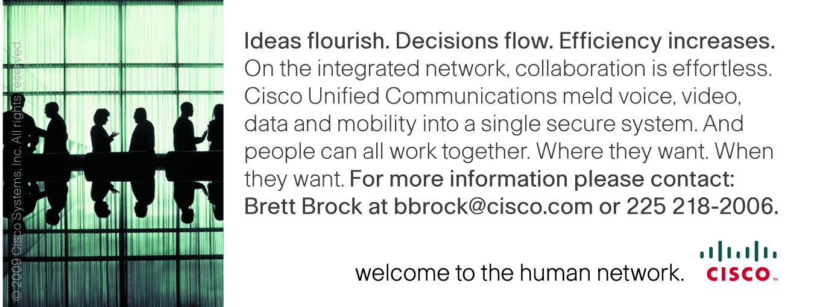

Notes

CISD Conference 2009

CISD Officers 2009

President
Mr. Greg Speyrer
Louisiana Community & Technical College System
First Vice President
Mr. Michael Carl
LSU Agricultural Center
Treasurer
Mr. David Dousay
Department of Wildlife & Fisheries
Secretary
Mr. Danny Ragan
La. Office of Financial Institutions
Immediate Past President
Mr. Douglas Bryant
LA Dept of Culture, Recreation & Tourism
Conference Committee Members:
Michael Carl Chairperson
Michael Riley Speaker Coordinator
Lata Johnson Hotel and Food Coordinator
Shannon Duplessis Understudy
Doug Bryant Audio/Visual & Network
Jim Burgard Vendor Registration Coordinator
Danny Ragan Attendee Registration Coordinator
Cindy Hadden Program Coordinator
Raj Jindal Program Printing
Moderator:
Kellee Hennessy
WAFB Channel 9, News Anchor
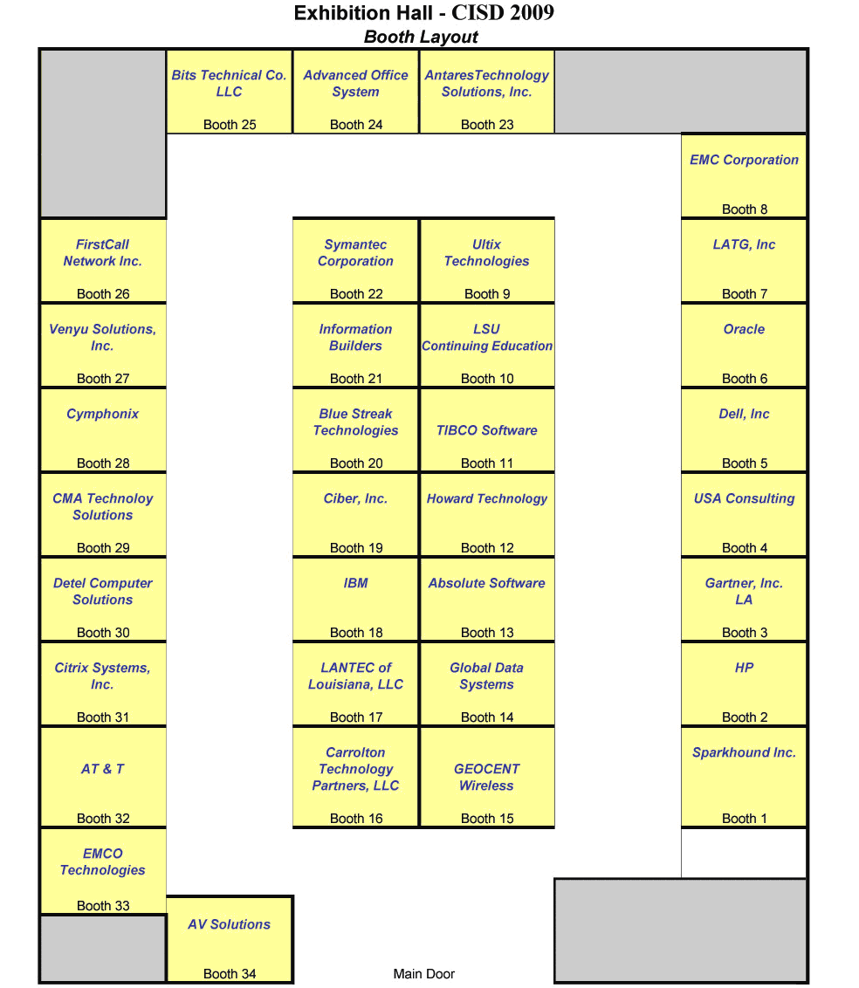

A special note to our public service colleagues: You are reminded that items offered to State of Louisiana employees by vendors during the conference are subject to the State of Louisiana Ethics statutes.
CISD makes no warrants or representations as to whether items offered to attendees by vendors conform with current Louisiana State Ethics statutes. If you have any questions as to whether it is appropriate to receive an item, please contact the Louisiana State Board of Ethics at 225-219-5600 or 800-842-6630.
In addition, information giving a summary of the applicable State Ethics Statutes and examples can be accessed via the following link:
http://www.ethics.state.la.us/Pub/InfoSheets/GiftsRev2-09.pdf

